# **Introduction**

The answer the 70 questions to assess security risk with respect to election activity in Pakistan is given below, the information is taken from official handouts provided by Election commission of Pakistan to DRO (District Returning Officers), RO (Returning Officers) and Election Act 1974. [All of the aforementioned documents are submitted with the report].

# **Training**

According to the handbook issued for District returning officers by Election Commission Pakistan (available on official website:<https://ecp.gov.pk/training-material>) it is an integral part of pre-poll preparation of elections to provide adequate training to the polling staff which also encompasses training them w.r.t. the security aspect of the elections.

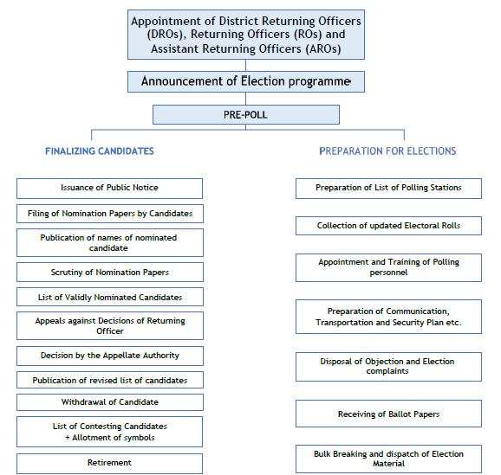The diagram below provides a detailed overview of the prepoll activities that need to be performed by the DRO (District Returning Officer). Preparing for the communication, transportation and Security Plan are an integral part of preparing for the elections.

Figure Pre-Poll Electoral Process

A/c to the DRO handbook issued the ECP, “**Ensuring that proper security, Transportation and Communication plan etc. is in place for safe transportation of election material and staff to the polling station and communication of result to the ECP.** ” is a prime responsibility of the District Returning Officer.

The presiding officer must, “**Take a full review of all security arrangements at polling station and only allow authorized persons i.e candidates, polling agents, election agent or persons having Accreditation Card from the Election Commission, the DRO or RO to enter the polling station other than voters.**”

# **Access Control**

According to the DRO handbook issued by ECP only, “**Election agent nominated by the candidate is authorized to access all the polling stations of the relevant constituency.**”

The Elections Act of 1974 in Pakistan primarily focuses on the legal and procedural aspects of elections rather than the technical details of access control during the electoral process. However, the security and access control measures during elections in Pakistan involve a combination of legal provisions, administrative practices, and technical measures to ensure the integrity of the electoral process.

The Elections Act and other relevant laws empower the Election Commission of Pakistan (ECP) to regulate and oversee the electoral process, including access to polling stations and counting centers.

Access control is maintained through the deployment of law enforcement personnel at polling stations and other election-related facilities. They are responsible for ensuring that only authorized individuals, such as voters, election officials, and accredited observers, are allowed entry.

Access to the voting process is controlled through the maintenance of accurate voter lists. Only registered voters are allowed to cast their votes, and a proper identification process is in place to verify the identity of voters.

# **End User (Voter)**

In order to educate the voter about the vote casting process, ECP conducts various voter awareness programs such as [ECP Voter outreach program](https://ecp.gov.pk/voter-awareness).

Furthermore, in order to verify the authenticity of the voter ECP takes the following steps:

* The Election Commission maintains updated voter lists, and only individuals whose names appear on these lists are eligible to vote. This list is a crucial tool for verifying the eligibility of voters.
* Voters are typically required to present their National Identity Cards (NICs) at the polling stations for identification. The NIC is a widely recognized official identification document in Pakistan.

The handbook for returning officers (RO) issued by the ECP (available on official website: <https://ecp.gov.pk/training-material>) also outlines the following principles for voter facilitation and ensuring the correct casting of votes.

* There should be no factor influencing the voters' choice on poll day.
* Each polling station will consist of 2-4 polling booths (depending on the number of voters assigned to each polling station).
* The Presiding Officer must ensure that Computerized Pictorial Electoral Roll (with photograph of voters) provided by the Returning Officer is used at the polling station.
* Ensuring that only voters registered on the Electoral Roll, are permitted to vote.
* Ensuring placement of Screened off Compartments at appropriate place so that secrecy of each voter is ensured.
* Take a full review of all security arrangements at polling station and only allow authorized persons i.e candidates, polling agents, election agent or persons having Accreditation Card from the Election Commission, the DRO or RO to enter the polling station other than voters.

# **End Points (Polling Station)**

In order to secure the polling stations and to ensure seamless conduction of elections the ECP handbooks prescribes the DRO to, “**declare Polling stations as highly sensitive, in consultation with head of District Police.**“

It is the responsibility of the DRO to, “**Ensure that proper security, Transportation and Communication plan etc. is in place for safe transportation of election material and staff to the polling station and communication of result to the ECP.**“

Furthermore, the official handbook of ECP also instructs to,

**“Appointing impartial polling staff at the polling stations. Submission of the list of polling staff (Presiding Officers, Assistant Presiding Officers and Polling Officers) appointed for the conduct of election, to the DRO (at least 14 days before the poll day) for approval.”**

The election Act 1974 has the following guidelines with respect to securing the polling stations on election day,

* Polling stations are designated as restricted areas during elections. Only authorized individuals, such as voters, election officials, and accredited observers, are allowed entry. Unauthorized individuals are restricted from entering the polling premises.
* Election officials and polling staff are trained to follow security protocols. They are briefed on procedures to handle potential security threats and emergencies.
* The Act or associated rules specify procedures for the sealing and opening of ballot boxes. This is done in a secure manner to prevent tampering and maintain the secrecy of the vote.
* Strict procedures for voter identification are often in place to prevent impersonation and ensure that only eligible voters cast their ballots. This may include the verification of National Identity Cards (NICs) and, in some cases, the use of biometric verification.
* ECP may invite local and international election observers to monitor the electoral process. Their presence contributes to transparency and can act as a deterrent to irregularities.

The Presiding Officer will act as Magistrate of the First Class as authorized by the Commission and will be responsible to maintain law and order at the polling station.

# **Security Architecture**

The Election Commission of Pakistan, employs security best practices to safeguard their systems and data.

**1. Principle of Least Privilege:**

The DRO handbook issued by the ECP states that, **“Election Agent must adhere to the principle of non-interference.”**

**2. Zero Trust Model:**

The election model in Pakistan also relies on independent observers to approve the elections, this can be termed as an iteration of zero trust model.

According to the DRO handbook independent observers perform the following actions during elections:

1. Observing all stages of the polling process, except stamping of a ballot paper by a voter.
2. Observer is not allowed to speak to any polling staff which may hinder their work.
3. Observing the counting of vote and if he/ she intends, sign the Result of the Count (Form-XI) and Ballot Paper Account (Form-XII).

**3. Multifactor Authentication (MFA):**

MFA is incorporated in the security model at various staged such as the official DRO handbook states that the District Returning Officer has the authority to issue accreditation cards to observers and media persons.

DRO should ensure that the applicant has provided requisite documents such as:

* Written application on letter head of organization along with details in respect of name, contact number and address of the observer.
* Letter from media house in case the applicant is from print or electronic media
* Two recent colored photographs and a photocopy of valid NIC

No person shall be allowed to observe the conduct of election, if he:

* is not accredited as an observer by the Commission or its authorized officer;
* is affiliated with any political party;
* fails to provide his full particulars and documents, including photographs;
* has been involved in activities prejudicial to the peace and tranquility of the people of a constituency;
* fails to provide an authorization from the organization of which he is a member.

**4. Credential Management**:

The Presiding officer must take a full review of all security arrangements at polling station and only allow authorized persons i.e candidates, polling agents, election agent or persons having Accreditation Card from the Election Commission, the DRO or RO to enter the polling station other than voters.